Activate_Windows_11_Pro_free

Getting started
What you first need to do is open CMD (Command Prompt) as Administrator using this keyboard key:
Windows-logo key+ R
And now type in "cmd.exe" in the box
It should now look as something like this:
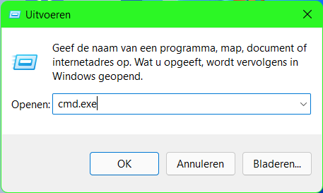
Now press this keys on your keyboard:
ctrl+shift+enter
Now you have something like this:
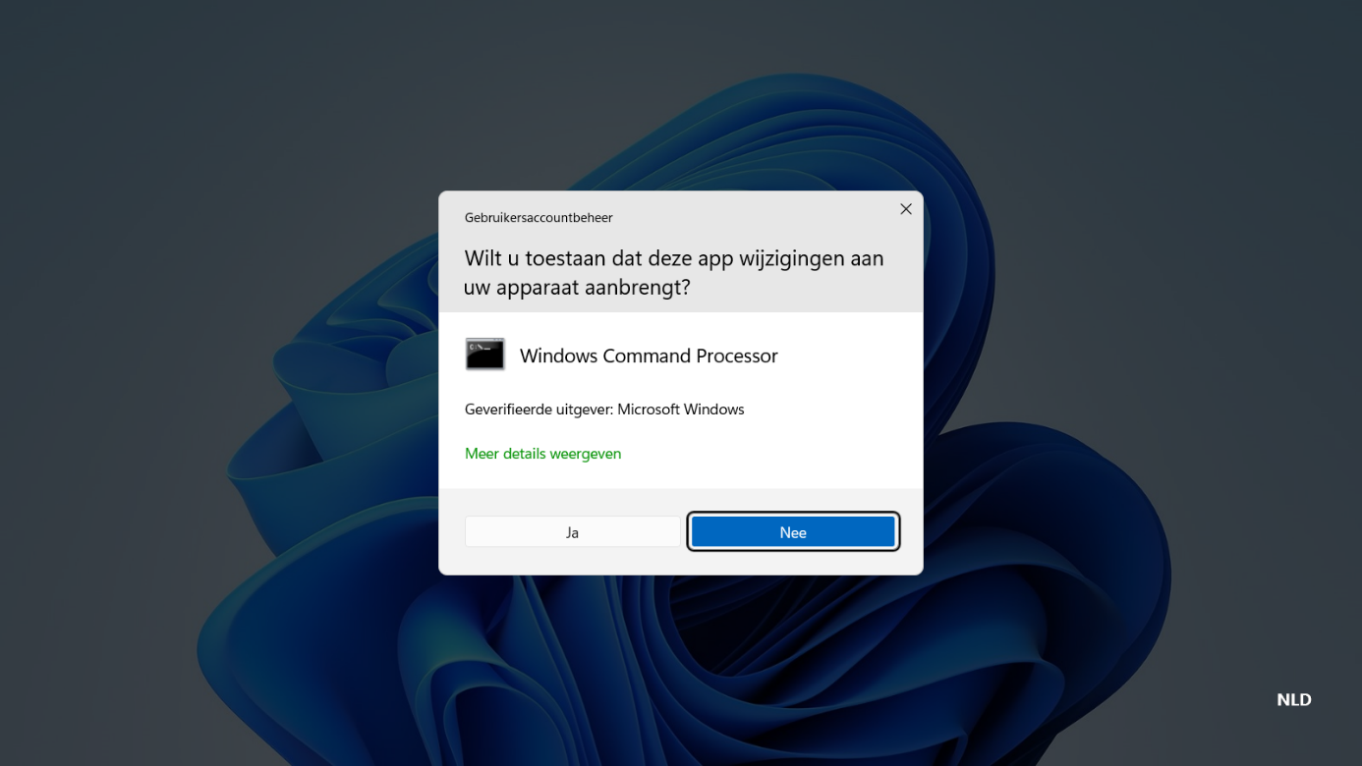
Now, click on "yes"
Now you have something like this:
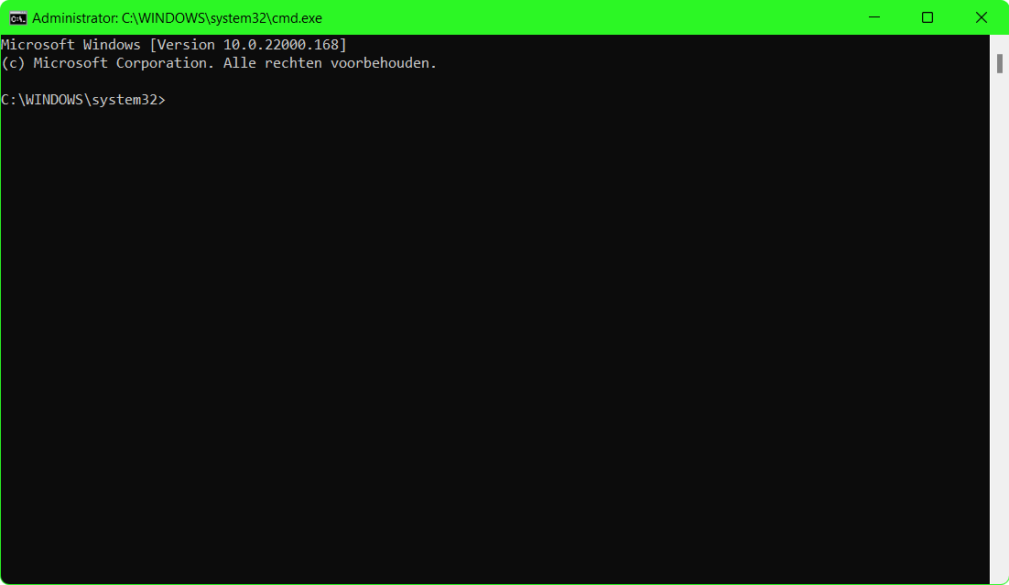

The commands
Now, type the following command: slmgr.vbs /upk Now it will give an message, click on OK
And now this command: slmgr.vbs /cpky It will give an message once again, and click on OK again
And now type this command: slmgr.vbs /ckms Once again click on OK when you get an message

Edition upgradable check command
Now we are going to check of your edition is supported to upgrade to Pro, run the following command to check this: DISM /online /Get-TargetEditions If you see "Professional" in the list, then you can upgrade your Windows edition to Pro for free!

Running Windows Pro installer
Now, copy and paste this complete command:
sc config LicenseManager start= auto & net start LicenseManager
sc config wuauserv start= auto & net start wuauserv
changepk.exe /productkey VK7JG-NPHTM-C97JM-9MPGT-3V66T
exit
It will run an installer and you will see a message:"% complete"
Now wait until it's 100% and it's not weird that you will get an error
When you get the error, just click Exit and then reboot your pc.
You will now see a message that he is running updates and is installing features, just wait until its done and check "info" in settings, you will see that Windows 11 Pro is installed!
But we are not done, you will see that it isn't activated and that you can't change some settings, now we are going to fix that!

Activating Windows Pro
Now we are going to run some other commands to activate Windows 11 Pro
Press these keyboard keys once again:
Windows-logo key+R
It looks like this again:
Press ctrl+shift+enter
You will get an message, just click on Yes
Now you will get an Command Prompt.
Type the following commands one for one to activate:
slmgr /ipk W269N-WFGWX-YVC9B-4J6C9-T83GX
slmgr /skms kms8.msguides.com
slmgr /ato
Now you have Windows 11 Pro and it activated! You can check settings to see it.

